PRACTICAL - 6
AIM: To study and design Wallace Tree Adder.
THEORY:
There are many cases where it is desired to add more than two numbers together. The straightforward way of adding together m numbers (all n bits wide) is to add the first two, then add that sum to the next using cascading full adders.
The Wallace tree has three steps:
- Multiply (that is – AND) each bit of one of the arguments, by each bit of the other, yielding n² results. Depending on position of the multiplied bits, the wires carry different weights, for example wire of bit carrying result of a₂b₃ is 32.
- Reduce the number of partial products to two by layers of full and half adders.
- Group the wires in two numbers, and add them with a conventional adder.
The second phase works as follows. As long as there are three or more wires with the same weight add a following layer:
- Take any three wires with the same weights and input them into a full adder. The result will be an output wire of the same weight and an output wire with a higher weight for each three input wires.
- If there are two wires of the same weight left, input them into a half adder.
- If there is just one wire left, connect it to the next layer.
This requires a total of m − 1 additions, for a total gate delay of O(m lg n) (assuming look ahead carry adders). Instead, a tree of adders can be formed, taking only O(lg m · lg n) gate delays.
A Wallace tree adder adds together n bits to produce a sum of log₂n bits.

Case 1: Wallace tree adder to add seven bits (W₇) is illustrated below:
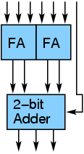

Case 2: Wallace tree adder to add three 4-bit numbers is illustrated below: | Case 3: Wallace tree adder to add five 4-bit numbers is illustrated below:
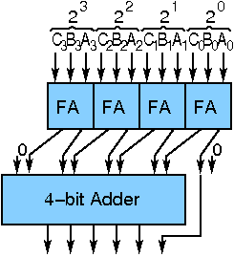 | 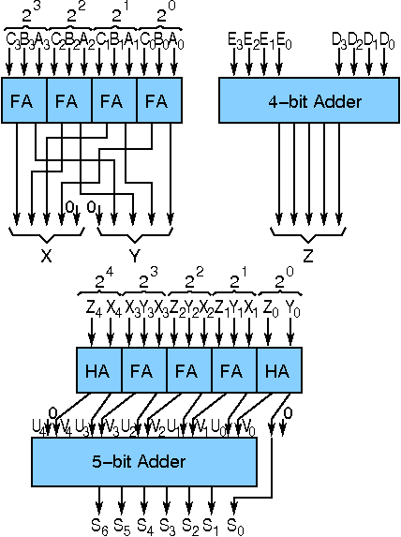
Components:
- Half Adder
- Full Adder
- 4-bit adder

LABWORK:
1. Addition of Seven Bits.
SOLUTION:
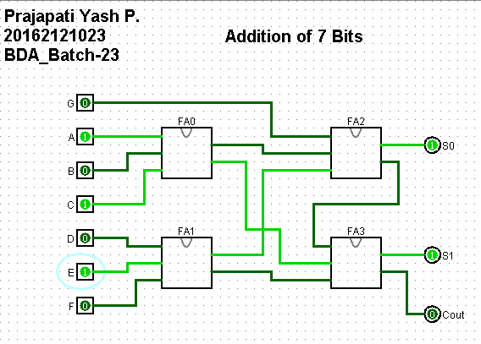

2. Addition of Three 4-Bit Numbers.
SOLUTION:
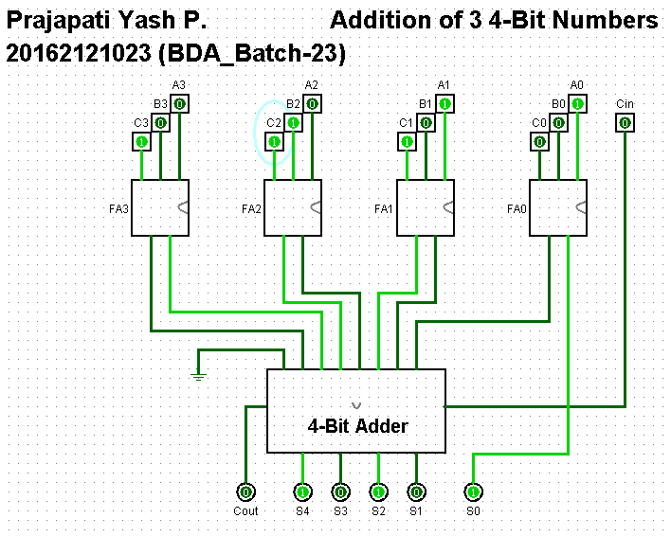
3. Addition of Five 4-bit Numbers.
SOLUTION:
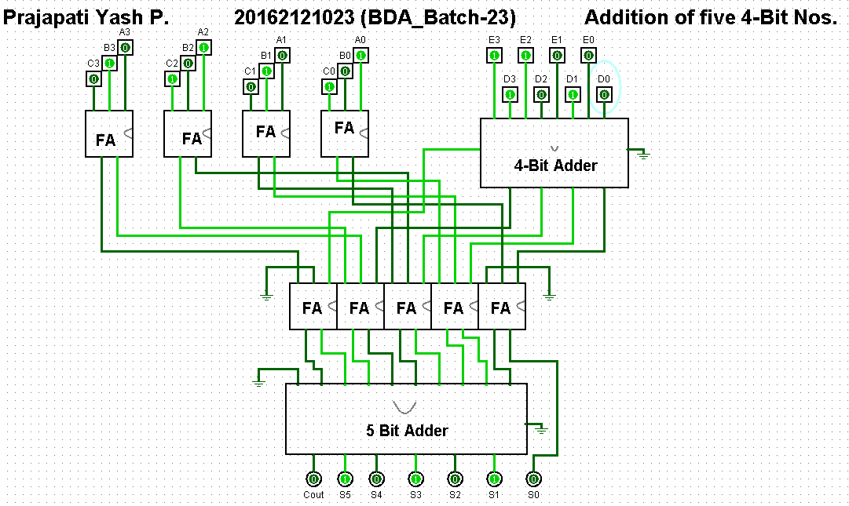

CONCLUSION:
Hence by studying the design and analyzing the results of the circuit, we conclude the study and design of Wallace Tree Adder.

